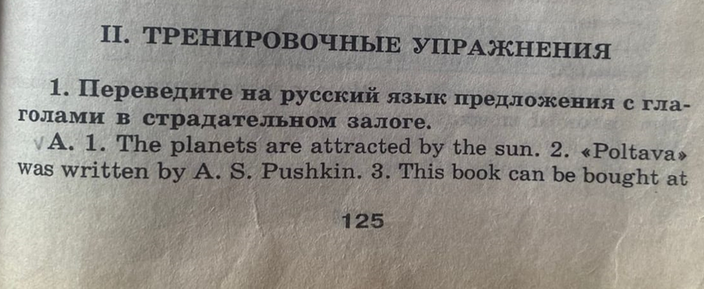

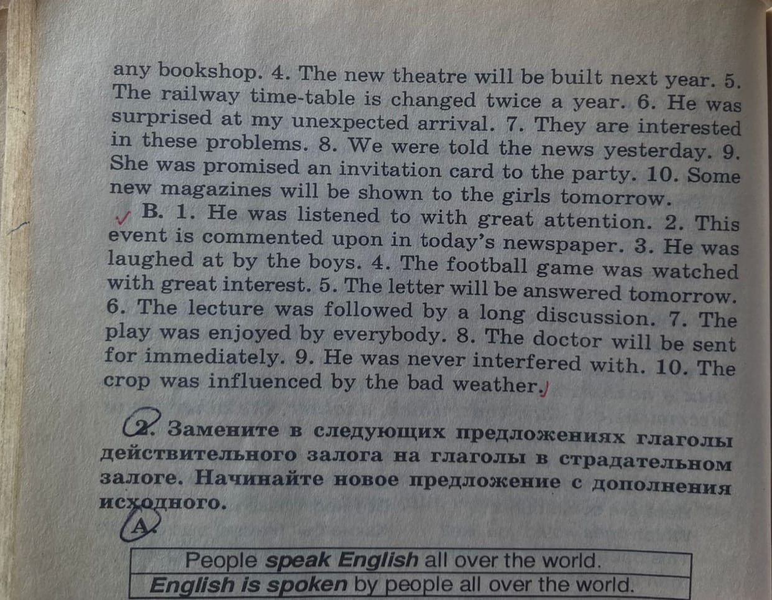

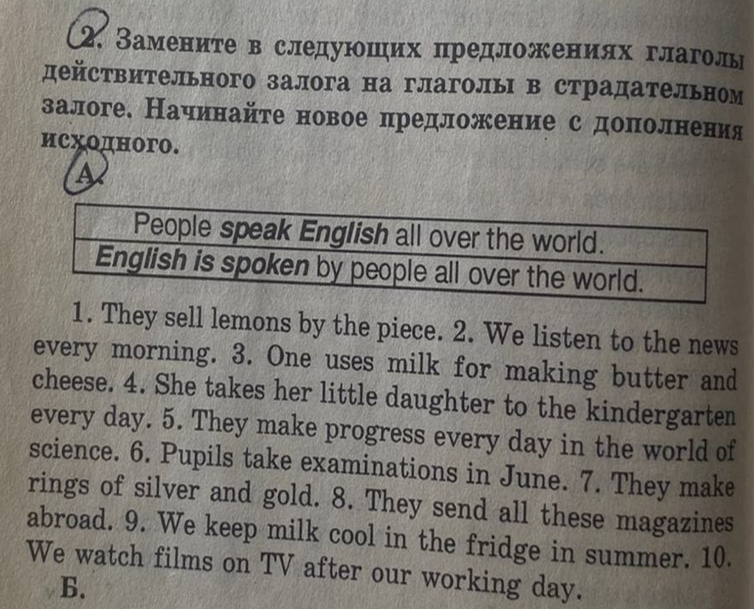

Таблица образования пассивного залога в разных временах

|  |  |  |  |
| --- | --- | --- | --- |
| Время | Сказуемое | | Пример |
| Present Simple | am/is/are | + written | It is written by Sam. – Это **написано** Сэмом. |
| Past Simple | was/were | It was written by Sam yesterday. – Это **было** **написано** Сэмом вчера |
| Future Simple | will be | It will be written by Sam tomorrow. – Это **будет** **написано** Сэмом завтра. |
| Present Continuous | am/is/are | + being written | It is being written by Sam now. – Это **пишется** Сэмом сейчас. |
| Past Continuous | was/were | It was being written by Sam at 10 a.m. yesterday. – Это **писалось** Сэмом вчера в 10 утра. |
| Future Continuous и Future Perfect Continuous | НЕ СУЩЕСТВУЕТ | | |
| Present Perfect | have/has | + been written | It has just been written by Sam. – Это **было** только что **написано** Сэмом. |
| Past Perfect | had | It had been written by Sam before I came back – Это **было написано** Сэмом до того, как я вернулся. |
| Future Perfect | will have | It will have been written by Sam by the end of July. – Это **будет написано** Сэмом к концу июля. |