Task 1

Degrees of Adjectives. Make a summary (The rule, formation, examples)

Task 2

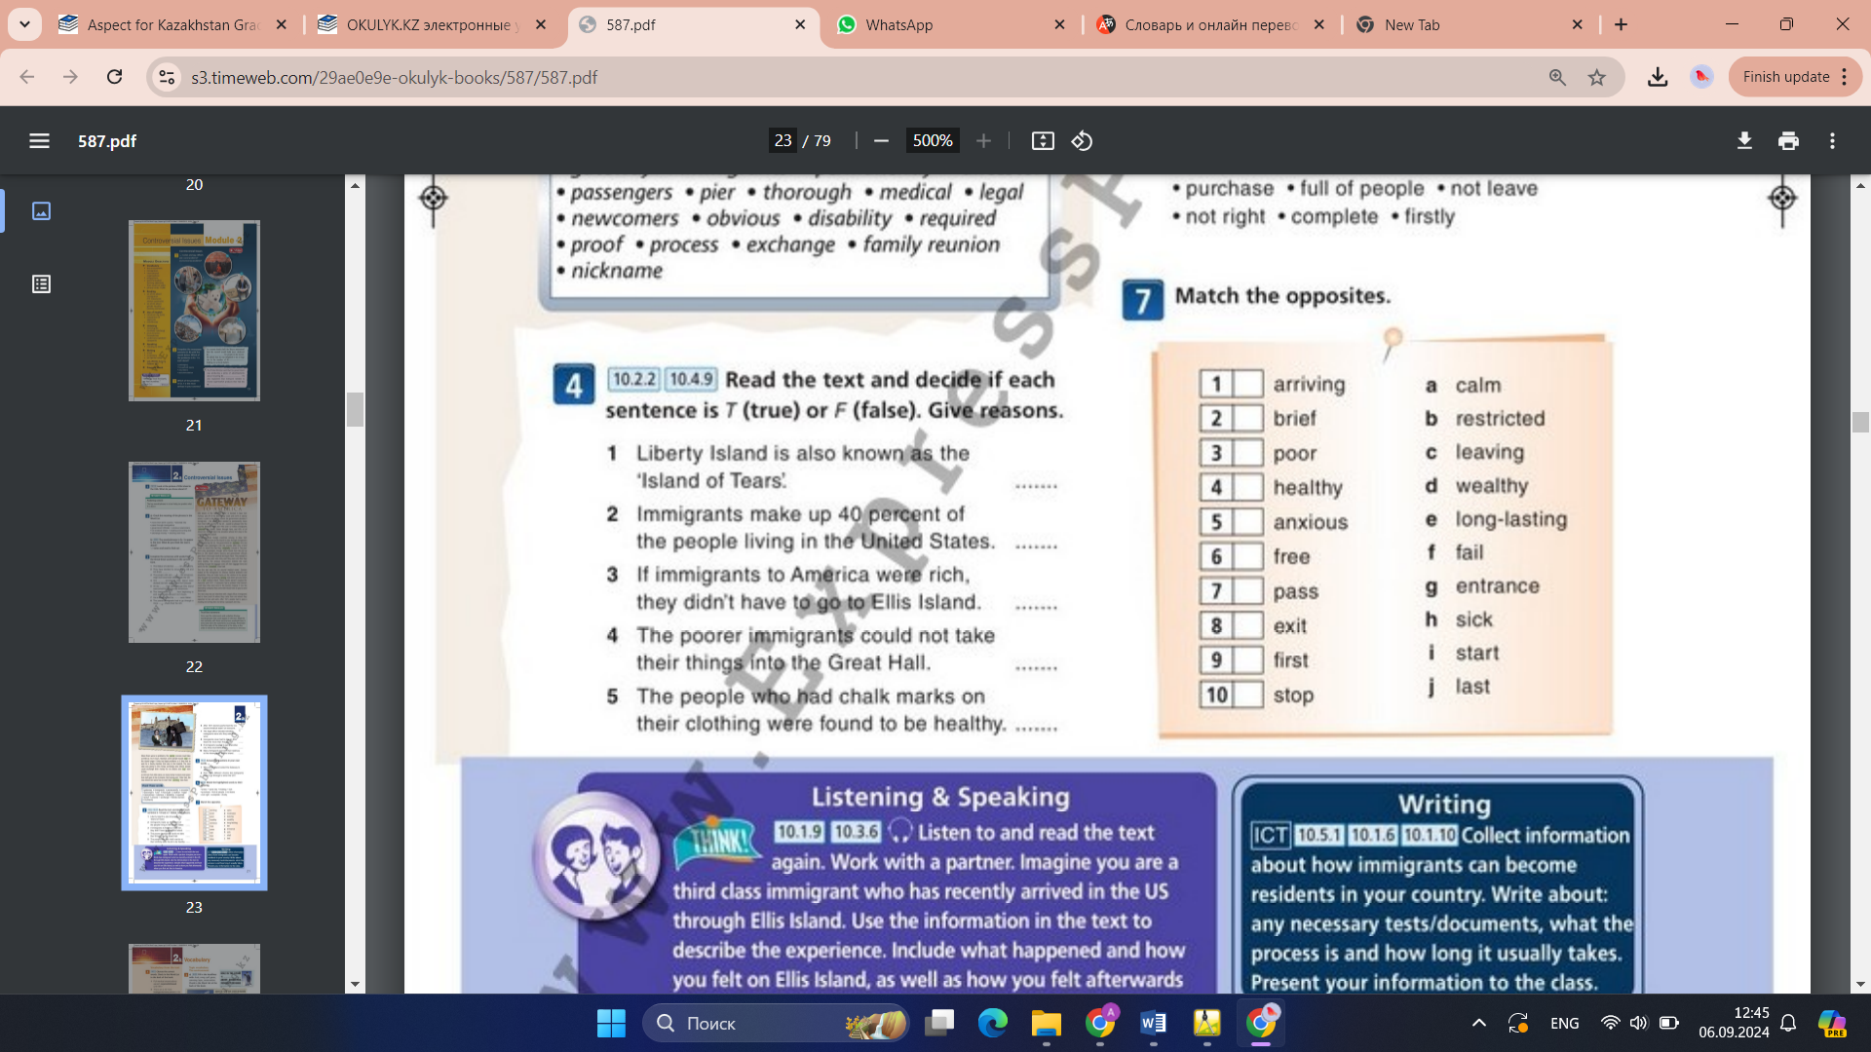

Task 3

Writing an essay “Pros and cons of immigration” (10-15 sentences)

Task 4

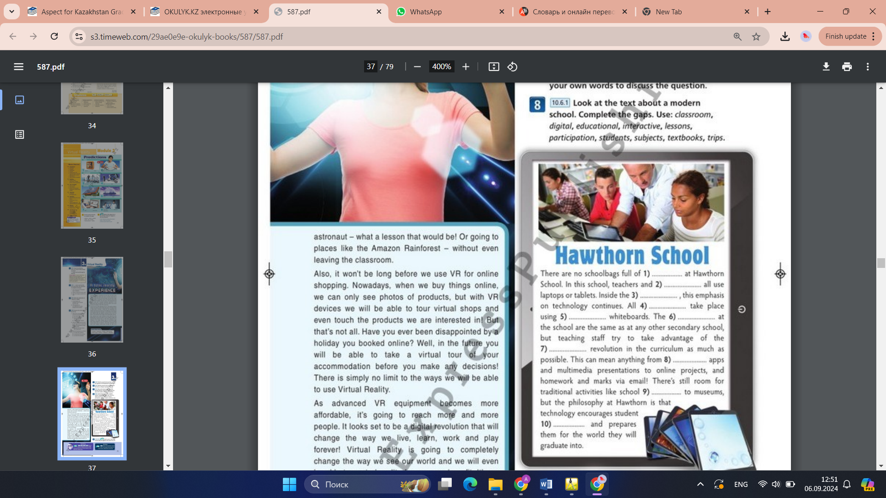

Task 5

A sci-fi film review. Around the World in eighty days.